February 2021

OPPORTUNITIES NOW
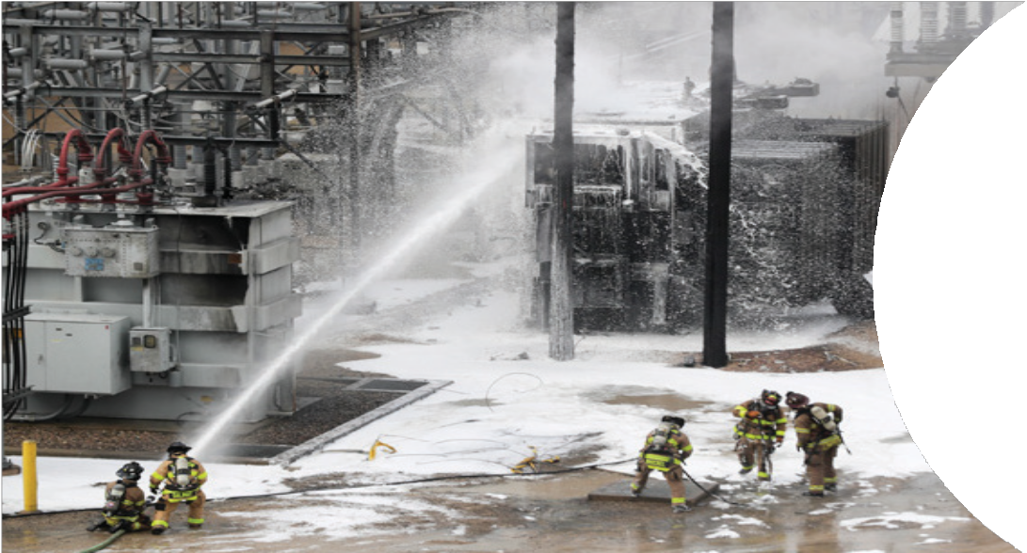
An Analysis of Priority Issues and Actions for Wisconsin’s Natural Resources

2021

2023

PFAS – Forever Chemicals in Wisconsin



PFAS – Forever Chemicals in Wisconsin

Contributors

Wisconsin’s Green Fire
BOARD OF DIRECTORS
Terry Daulton, President Jim Perry, Vice President Robin Schmidt, Secretary Robert Gurda, Treasurer
Michael Cain Ron Eckstein
Jodi Habush-Sinykin
Tom Jerow Paul LaLiberte Bob Martini Mike Meyer Bryan Pierce Kate Reilly
Shannon Thielman
Fred Clark,
Executive Director
Sarah Peterson John Robinson Meleesa Johnson Tom Jerow James Baumann Fred Clark

About this Work:
Opportunities Now is an issue paper series published by Wisconsin’s Green Fire that summarizes the science and background of key conservation and environmental issues and makes policy recommendations that support pro-conservation outcomes. Each of the papers in our Opportunities Now series is the product of an analysis of current literature, interviews with agency staff and experts, and the consensus of our subject matter teams. Policy makers, conservation organizations, and concerned
citizens are all welcome to use and distribute Opportunities Now papers without restrictions.

Direct Jnquiries on this paper to WGF Science Director Sarah Peterson, at speterson@wigreenGJSe.org

Cover photo: Aqueous Film Forming Foam containing PFAS at use in a fire at a Dity of Madison electric substation in July, 2019. Photo credit: Wisconsin State Journal.

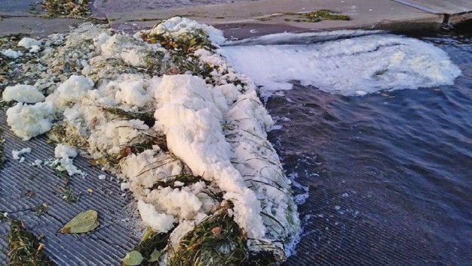

Foam containing PFAS found in Starkweather Creek, Madison, Wisconsin. Photo Credit: WDNR.

PFAS – Forever Chemicals in Wisconsin
Countries across the world are grappling with the long-term health and environmental impacts related to the manufacturing and use of the large family of chemicals known as PFAS, or Per- and Polyfluoroalkyl Substances. PFAS are often called “forever chemicals” due to a molecular structure that gives them extraordinary persistence in the environment and the ability to resist decomposition.

PFAS as a group includes thousands of individual chemicals, many of which have been in production and use in a wide variety of products since at least the 1950s. PFAS are especially valued for their ability to resist grease, stains, oil, water, and heat and are found in many everyday products such as firefighting foam, carpeting, coated paper, chrome metal plating, nonstick cookware, dental floss, and a wide variety of food packaging. Due to their widespread use in so many consumer products, PFAS are now being detected in the environment and in humans, animals, and other organisms in every part of the world.
Exposure to high levels of PFAS has been linked to a myriad of human health issues including increased risk of some cancers, decreased vaccine response in children, changes in liver enzymes, and fertility and pregnancy complications in women.1
In the last 15 years PFAS have been found in groundwater, surface water, drinking water wells, as well as in biosolids, soils, and aquatic sediments in Wisconsin. In the absence of a comprehensive federal approach to PFAS, Wisconsin, along with other states, is now grappling with how to regulate these chemical contaminants while working to better understand their health effects.
Like many other states, Wisconsin currently lacks enforceable standards for PFAS in
surface water, groundwater, and drinking water.



Johnson Controls - Tyco Fire Products Stanton Street Facility located on the Menominee River in Marinette has been a documented source of
PFAS contamination. Photo
$redit: Fred Clark.

The lack of state enforceable standards is compounded by the lack of federal standards o the United States Environmental Protection Agency (EPA) currently has not established enforceable standards* for any PFAS chemical. The EPA has established non-regulatory health advisory levels for drinking water of 70 parts per trillion (ppt) or two oG the most tested-Gor PFAS chemicals, perfluorooctanoic acid (PFOA) and perfluorooctane sulfonate (PFOS), combined.
One of the earliest PFAS chemicals to be studied, PFOS, was voluntarily phased out of use in 2002 in the United States. U.S. Manufacturers voluntarily eliminated PFOA emissions and their use in products by the end of 2015. Despite these actions numerous other PFAS known as “short chain PFAS” are still in use.2
Short chain PFAS contain fewer fluorine atoms than long chain PFAS and have been reported in manufacturersh studies to be safer and less likely to bioaccumulate.3 Recent toxicity studies however show that second generation short-chain PFAS chemicals have comparable toxicity with longer chain chemicals, affecting the same organ systems, similar to the effects of the older longer chain PFAS.4
In the absence of federally enforceable standards for PFAS, states are left to devise their own standards and response. The Wisconsin Department of Health Services (WDHS) has recommended a health-based standard of 20 ppt for PFOA and PFOS combined, in groundwater. As of December 2020, a Wisconsin Department of Natural Resources (WDNR) rulemaking process is underway to develop statewide standards for PFAS in drinking water, ground, and surface waters.
*Enforceable Standards are regulatory limits for contaminants that require corrective action when exceedances occur. Health advisory levels are non-regulatory thresholds that trigger public advisories.

This report provides a look into sources of exposure, health effects, and
known releases for PFAS in Wisconsin, as well as state agency involvement. Recommendations in the report point to improved environmental management of PFAS grounded in the latest science, methods to reduce exposure and devise clean up procedures for spills that occur.

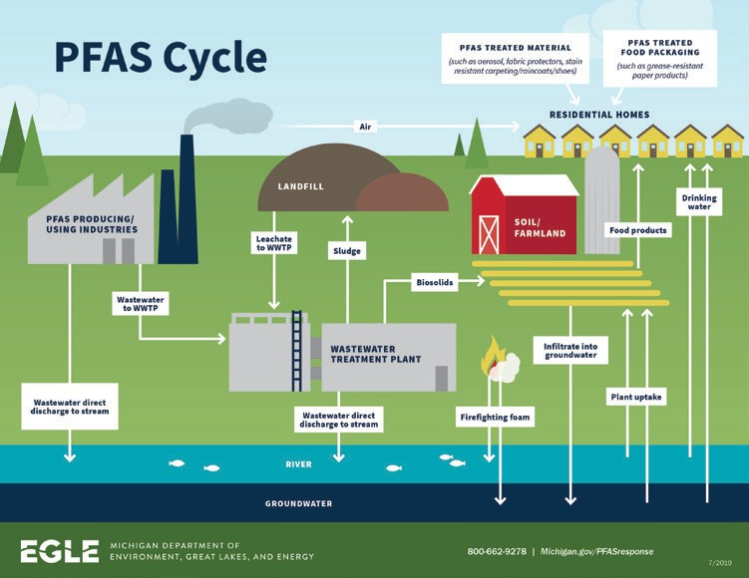

How PFAS cycle through the environment, their fate and transport. Credit: Michigan Department of Environment, Great Lakes,
and Energy

Background

Routes of Exposure
PFAS have a unique chemical structure that contributes to their persistence. PFAS molecules contain a hydrophobic (or water repellent) fluorine-saturate carbon chain and a hydrophilic (attracted to water) functional group. This structure gives PFAS their desirable water and fat repellent quality that makes them perfect for nonstick and water repellent products, but it also contributes to their exceptional persistence in the environment.5
Detecting and managing PFAS is complex, in part due to the numerous points within the manufacturing and distribution systems and the waste streams where PFAS and products containing PFAS enter the environment. Human exposure may occur at any of these points.
Homes, work places, hospitals and even schools can also be sources of PFAS exposure because of commonly used items, which may include:6
- Stain-free carpeting, draperies, and furniture
- Grease and moisture-resistant paper products such as fast-food wrappers, dry goods packaging, and medical gowns and curtains7

  - Non-stick pans and cookware
  - Building products such as plumbing tape, house wraps and paints
  - Outdoor rain-resistant fabrics and gear
  - Personal care products like lotions,
cosmetics, and dental floss
  - Fabric softeners
Through their regular use, humans become exposed to PFAS that leach from cooking pans or by breathing PFAS- laden dust loosened from fabrics. As these items are discarded, they enter the environment, either through the solid waste stream, or directly to air or water. Whether recycled, landfilled, composted, or incinerated, PFAS remain in the air, water, and soil because of their persistent nature.
PFAS have been found in wastewater effluent and in industrial and municipal waste system biosolids (the solid fraction that remains after wastewater treatment). Biosolids from wastewater treatment plants (WWTPs) are often land-spread on farm fields as a soil amendment or sent to solid waste facilities for management. PFAS can be
reintroduced back into the environment when present in biosolids. Studies have also shown that plants have the ability to uptake PFAS from PFAS-laden soil.8
Another common entry point for PFAS to the environment is through the
use of aqueous film-forming foams (AFFFs) used in municipal airport and airfield firefighting. Firefighting training exercises at military air bases have commonly led to releases of PFAS to surface and groundwater.
Documented releases have occurred across the state at all three of Wisconsin’s Air National Guard bases.

Health Effects
PFAS chemicals bind to proteins, particularly in the liver and blood.9 Preliminary research suggests that high levels of PFAS may increase cholesterol levels, decrease how well the body reacts to vaccines, result in changes in liver enzymes, increase the risk of certain cancers, increase the risk of pregnancy compilations such as pre-eclampsia and lower average birth weights in newborns.1, 10 Reducing human exposure to PFAS is difficult, however, due to

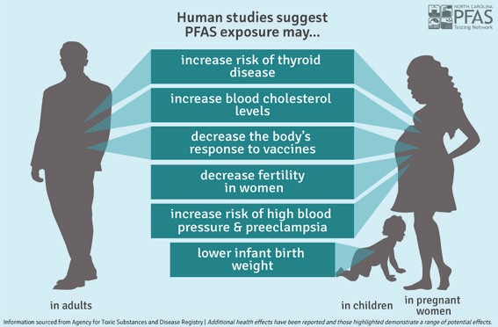
Research suggests a variety of human health impacts from PFAS exposure.
Credit: Agency for Toxic Substances and Disease Registry.

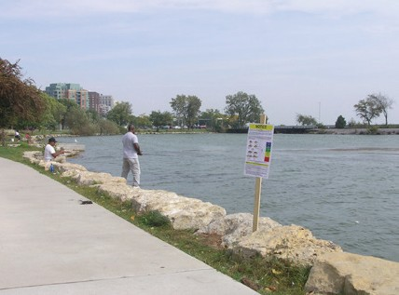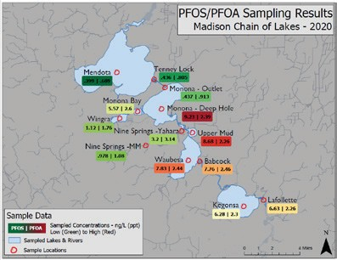

Lake Monona shoreline anglers fish next to a fish consumption advisory notice in Madison, WI. Photo credit: Midwest Environmental Advocates.
Map based on 2020 sampling showing elevated levels of PFOS and PFOA compounds in the Madison Chain of Lakes. Credit: WDNRR

multiple sources of exposure and the widespread use PG 1'"4 in everyday life.
Due to their resistance to degradation in the environment, PFAS compounds
have high potential for bioaccumulation and biomagnification and toxicity to organisms.5 Fish advisories are commonly issued following known releases of PFOS to the environment or in areas where PFAS has been a persistent problem.11
A recent WDNR study also found PFOS in the livers of deer near the Johnson Controls International (JCI)/Tyco site in Marinette.12
The manufacture, incineration, and disposal of PFAS chemicals has inordinate impacts on vulnerable communities.
Multiple studies have shown that low- income communities and communities of color are more likely to live near PFAS- contaminated areas and face exposure to bioaccumulating PFAS toxins found in fish due to a higher reliance on subsistence fishing activities.13, 14

Known Areas of Contamination in Wisconsin
Notable sites with high-profile releases
include:
- MIRRO Plants in Manitowoc and Chilton: former manufacturing facilities
- JCI/TYCO site in Marinette: manufacture and testing of firefighting foam
- 2018 Husky Energy Refinery in Superior: use of firefighting foam to suppress an explosion and fire
- 2019 MG&E Substation Transformer in Madison: use of firefighting foam to suppress an explosion and fire
- Truax Field in Madison: use of firefighting foam in training exercises requiring fire suppression
- Volk Field at Camp Douglas and Fort McCoy: use of firefighting foam in training exercises requiring fire suppression
- General Mitchell Airport in Milwaukee: use of firefighting foam in training exercises requiring fire suppression
- Refuse Hideaway Landfill in Middleton and Junker Landfill in Hudson: leachate containing PFAS

As of October 2020, there were 47 documented releases of PFAS into the environment in Wisconsin

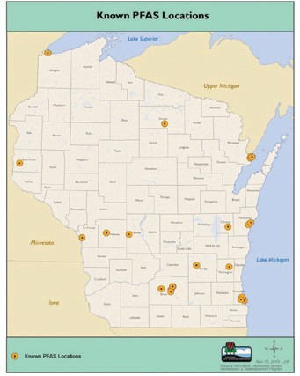
Known PFAS locations in Wisconsin. Source: Wisconsin Department of Natural ResourcesR
The known PFAS releases in Wisconsin have resulted in impacts to public and private water supply wells at several sites including wells in the Peshtigo/Marinette area (JCI/TYCO), Rhinelander Municipal Well #7, La Crosse Municipal Wells 23 &24. In August 2020, Madison Water Utility reported PFAS in all 22 of its active wells with total PFAS concentrations ranging from 2.5 to 47 ppt.15
Due to concerns over the uptake and bioaccumulation of PFAS
in deer livers from grazing on Gields impacted by PFAS runoGG
or landspreading of biosolids, the WDHS and the WDNR have
recommended that hunters do not eat liver harvested from deer within the PFAS advisory area around the JCI/TYCO site.13

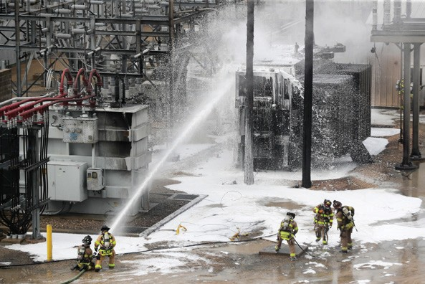
Aqueous Film Forming Foam containing PFAS at use in a fire at a City of Madison electric substation in July, 2019. Photo credit: Wisconsin
State Journal.

The lack of information relating to the historic use and release of PFAS is one of the biggest limitations in effectively
managing this threat. Our understanding of the extent and distribution of PFAS contamination in Wisconsin is still incomplete but growing as additional sampling occurs and new information becomes available.

Monitoring in Wastewater Treatment Plants Wisconsin
Current monitoring for PFAS in Wastewater Treatment Plants (8851T) is incomplete and insufficient, partly due to the lack of enforceable environmental standards and the lack of adequate agency authority. Most of the monitoring that has occurred at WWTPs to date has either been done by the WDNR or done by WWTP operators on a voluntary basis.
Understanding the level of PFAS in JOGMVFOU, FGGMVFOU, and biosolids at WWTPs is critical to developing regulations and water quality standards. This information would help provide an understanding of the potential routes for human exposures through the consumption oG Gish, wildliGe, and drinking water.

Treatment, Containment, and Remediation
Effectively treating and destroying PFAS is an area of emerging research. Membrane bioreactors, granulated activated carbon, ion exchange resins, ultraGJMUSBUJPO, reverse osmosis, electrochemical oxidation,
electrocoagulation, and concentrators are all methods being evaluated and some are in early stage use.16 None
of these methods achieves complete remediation however as each method leaves residual PFAS in filters, membranes, and resins. Methods for destroying PFAS through incineration also result in incomplete remediation and leave behind residual PFAS.
All of the known remediation methods for PFAS also carry high costs and available funding is nowhere near adequate to address the known problem areas today. The U.S. Department of Defense (DOD) estimated that the cost to cleanup PFAS contamination at DOD installations alone would exceed $3 billion.17

Wisconsin State Government: Policy and Agency Capacity
PFAS were identiGJed as a priority issue during multiple public hearings hosted by the 2019 Wisconsin State Assembly Water Quality Taskforce.18
Only one of the proposals introduced during the 2019-2020 legislative session was enacted into law. 2019 Wisconsin Act 101 limits the use and discharge (with limited exceptions) oG Class B GireGJghting foams that contains intentionally added PFAS. A WDNR emergency rule to implement Act 101 was approved on December 9, 2020 by the Wisconsin Natural Resources Board. On December 18th, the Wisconsin Legislature’s Joint Committee on Review of Environmental Rules (JCRAR) voted to eliminate key provisions from the rule that addressed containment of PFAS contaminated material, rendering an important intent of the legislation ineffective.
In August 2019, Governor Evers issued Executive Order 40, which established a Wisconsin PFAS Coordinating Council, (since renamed the Wisconsin PFAS Action Council, or WisPAC). The Council was tasked with developing statewide standards for drinking water, ground water, and surface waters.
On December 16, 2020 WisPAC released a PFAS Action Plan that included a broad set of recommendations for environmental and health standards, pollution prevention, engagement
and communication, research, bans and
the phasing out of PFAS chemicals,

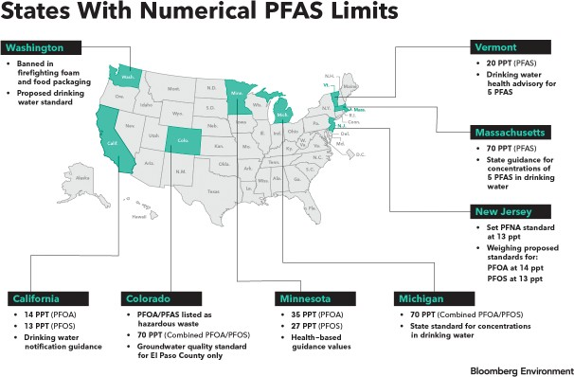
In the absence of federal standards, the states in green have been developing numerical standards. Since 2018, several other states have also commenced standard- setting processes.
States With Numerical PFAS Limits
- 70 PPT (Combined PFOA/PFOS)
- State standard for concentrations in drinking water
- 35 PPT (PFOA)
- 27 PPT (PFOS)
- Health-based guidance values
- PFOA/PFAS listed as hazardous waste
- 70 PPT (Combined PFOA/PFOS)
- Groundwater quality standard for El Paso County only
- 14 PPT (PFOA)
- 13 PPT (PFOS)
- Drinking water
notifcation guidance
- Set PFNA standard at 13 ppt
- Weighing proposed standards for:
PFOA at 14 ppt PFOS at 13 ppt
- 70 PPT (PFAS)
- State guidance for concentrations of 5 PFAS in drinking water
- 20 PPT (PFAS)
- Drinking water health advisory for 5 PFAS
- Banned in frefghting foam and food packaging
- Proposed drinking water standard
Source: Bloomberg Environment, 2018.

program funding, environmental justice issues, and addressing the historic legacy of PFAS discharges and exposures.
WDHS has recommended health standards of 20 ppt for PFOS and PFOA. WDNR is in the process of incorporating the proposed standards into drinking and groundwater
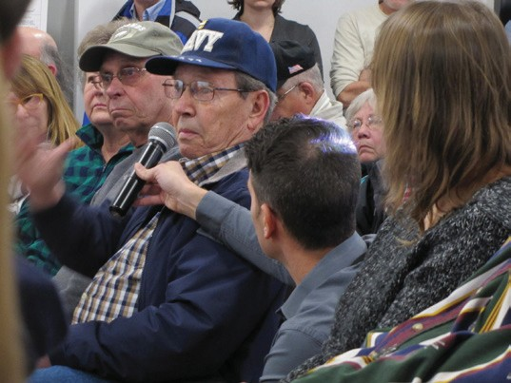
standards. WDNR is also developing surface water quality standards for other PFAS chemicals. The agencies are seeking input from the public through stakeholder meetings.
All of the efforts to develop administrative rules and standards are processes that can take as much as three years, however delays caused by
COVID-19 restrictions

Marinette, Wisconsin residents voice their concerns around PFAS exposure and cancer at a public listening session in January 2020. Photo Credit: Susan Bence.

Madison, Wisconsin residents organize to urge the Wisconsin Air National Guard to investigate and clean up PFAS chemicals in 2018. Photo Credit: Steve Apps/Wisconsin
State Journal.
on meetings may cause further delays. Given the urgency of human health aspects of PFAS, WDNR may use the emergency rule process to provide guidance for enacting drinking water standards sooner.

Conclusion
Although PFAS have been known in Wisconsin for at least 15 years, the issue is gaining increased attention as an important public health concern. In the absence of federal action, the Wisconsin environmental and public health community is beginning to understand the reach and scope of the problem.

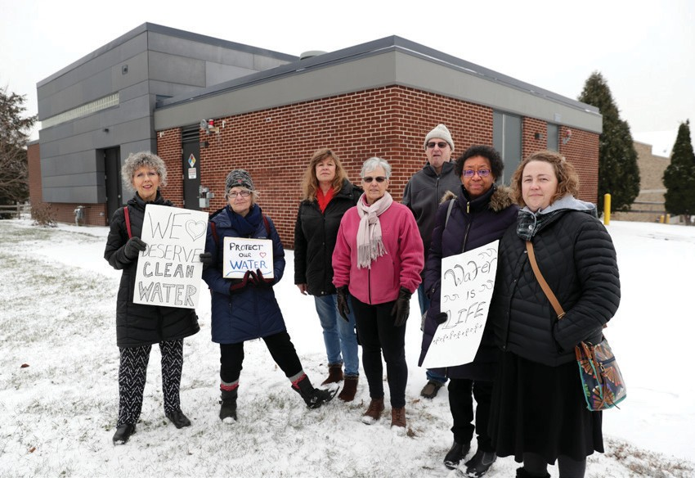

In order to properly address PFAS in the environment and protect human health, Wisconsin must take a holistic, comprehensive, and science-based approach to managing these forever chemicals. This will require collaboration in the ways that PFAS are managed, working closely with all the players in the PFAS cycle from manufacturing to disposal, educating the public on limiting exposure,
and using the best available science to guide decision-making and passing
necessary legislation.

Recommended Actions
� = Executive Action $ = Budget = Policy

Contamination by PFAS is known to have disproportionate effects on low-income communities and communities of color. PFAS action should adopt a “no-harm” approach that avoids placing additional burden on these communities and giving priority to sampling, monitoring, and abating PFAS contamination in communities with known releases.

Wisconsin Department of Natural Resources will be the primary agency in regulating PFAS use and remediation. Wisconsin Department of Health Services (WDHS) will play a supporting role.

Identify sources of PFAS exposures and releases
  - �Require that all public water supplies begin testing for multiple PFAS compounds no later
than the 2021-2022 state fiscal year and the
results of those tests should be publicly available.
  - �Require statewide sampling of PFAS in the
influent, effluent, and biosolids of municipal and
industrial wastewater treatment facilities no later
than the 2021-2022 state fiscal year.
  - �Use the results of the sampling of public waste supply systems and wastewater
treatment systems to identify PFAS clean systems and the systems with risk.
  - �Collect, assemble and make available representative data from a subset of Wisconsin
dischargers as part of the rule development process. This action will support the ongoing administrative rule processes for drinking water Ch NR 809 Wis. Admin. Code, groundwater Ch NR 140 Wis. Admin. Code, and surface waters/ wastewater $I NR 102 to NR 211.
  - �Expand understanding of the prevalence of PFAS in the environment, through the
collection of randomized data in watersheds and ecosystems in Wisconsin. The data can serve as the basis for development of environmental
standards. Wisconsin can look to neighboring states such as Minnesota and Michigan to compare and evaluate standards.

Develop science-based statewide standards that are protective of human health and the environment

  - � Establish science-based environmental standards for drinking water, groundwater,
and surface waters for PFOA and PFOS. In a second phase, establish standards for other PFAS compounds.

  - � Support expediting cleanup standards by using the emergency rule process for soil,
groundwater, and drinking water standards. Establish science-based standards for biosolids application to cropped fields and other lands, for solid waste and soil, and sediment associated with remediation/cleanup projects.
  - $ Support additional research into PFAS
in drinking water, surface water, wastewater,
and groundwater across the state, as well as studies on health and environmental impacts. This includes sampling fish tissues and blood serum from wildlife near suspected sources.





11 WISCONSIN’S GREEN FIRE, 2020

 = Executive Action $ = Budget = Policy

Manage environmental PFAS contamination and devise cleanup procedures for PFAS-containing media
  - $ Build off WisPAC recommendations on disposal, and direct research dollars towards
encouraging the development of innovative approaches to understand how PFAS can be safely destroyed.
  - $ Provide funding for PFAS remediation
efforts for fire departments, municipalities, small
businesses, and waste water treatment plants.
  - Amend the Cooperative Agreement between WDNR and the Department of Defense
(DOD) to ensure a full evaluation of the fate and transport of PFAS associated with contaminated DOD sites across the state.

Control sources of PFAS and identify methods to reduce exposure to contamination
B. Incentivize voluntary and regulatory approaches to control PFAS at the manufacturing source by limiting or eliminating their distribution and use in the supply chain. Consider phasing out the use of short-chain and new generation PFAS from food packaging.

- Develop legislation to encourage product stewardship and extended producer
responsibility o closing the loop on management and end-of-life care of PFAS wastes. Producers, wholesalers, retailers, and users of PFAS products, need to share the costs of disposal and cleanup.
- 'VOE B DMFBO TXFFQ QSPHSBN GPS DPMMFDUJPO BOE EJTQPTBM PG VOVTFE 1'"4 $MBTT # GJSFGJHIUJOH GPBN.

Lead an educational campaign to inform the public on how they can act personally to reduce their exposure to PFAS
  - Support consumer groups and partner organizations in their ability to properly dispose of
household materials containing PFAS.
  - Assist consumer groups and partner organizations in making informed decisions
about the products they buy and whether PFAS may be found in those products.
  - Support efforts to create a PFAS single point of contact to coordinate communication both
within the WDNR but also within state agencies to develop targeted and consistent messaging on PFAS. A designated person who can champion the issue is critical.
  - Coordinate state agency development of PFAS-related educational material for the
classroom.
  - Encourage WisPAC to host a PFAS summit to provide a forum for sharing information and the
latest research.






12 WISCONSIN’S GREEN FIRE, 2020

Literature cited
1 Agency for Toxic Substances and Disease Registry. 2020. Per- and Polyfluoroalkyl Substances (PFAS) and Your Health. https://www.atsdr.cdc.gov/pfas/health-effects/index.html
2 National Toxicology Program: U.S. Department of Health and Human Services. 2020. Immunotoxicity Associated with Exposure to Perfluorooctanoic Acid (PFOA) or Perfluorooctance Sulfonate (PFOS). https://ntp.niehs.nih.gov/whatwestudy/assessments/noncancer/completed/pfoa/index.html
3 Andrews, D. 2020. FDA Studies: 'Short-chain' PFAS Chemicals More Toxic Than Previously Thought.
Environmental Working Group. https://www.ewg.org/news-and-analysis/2020/03/fda-studies-short- chain-pfas-chemicals-more-toxic-previously-thought
4 National Toxicology Program. Per- and Polyfluoroalkyl Substances (PFAS). 2020. https://ntp.niehs.nih.gov/ whatwestudy/topics/pfas/index.html
5 NGI. Reducing Negative Impacts of PFAS. https://www.ngi.no/eng/Projects/Reducing-negative-impact- of-PFAS/PFAS
6 United States Environmental Protection Agency. PFOA, PFOS and Other PFASs: Basic Information on PFAS.
https://www.epa.gov/pfas/basic-information-pfas
7 3M. 3M's Commitment to PFAS Stewardship. https://www.3m.com/3M/en_US/pfas-stewardship-us/
8 Blaine, A., C. Rich, L. Hundal, C. Lau, M. A. Mills, K. M. Harris, and C. Higgins. 2013. Uptake of perfluoroalkyl acids into edible crops via land applied biosolids: Field and greenhouse studies. Environmental Science and Technology. John Wiley & Sons, Ltd., Indianapolis, IN, 47(24):14062-9.
9 Jones, P.D., W. Hu, W.D. Coen, J.L. Newsted, and J.P. Gisey. 2003. Binding of perfluorinated fatty acids to serum proteins. Environmental Toxicology and Chemistry. 11:2639-49. https://pubmed.ncbi.nlm.nih. gov/14587903/
10 Waterfield, J., M. Rogers, P. Grandjean, M. Auffhammer, and D. Sunding. 2020. Reducing exposure to high levels of perfluorinated compounds in drinking water improves reproductive outcomes: evidence from an intervention in Minnesota. Environmental Health. 19:42. http://www.documentcloud.org/ documents/7205135-REPORT-Grandjean-2020-PFAS-ReproductiveImpacts.html
11 Williams, M.C.W. and C.S. Shrank. 2016. Perfluorinated compounds (PFCs) in fish from Wisconsin s major rivers and Great Lakes. Administrative Management Report No. 83. Wisconsin Department of Natural Resources, Madison, Wisconsin, USA. https://dnr.wi.gov/files/PDF/pubs/fh/AdminReports/FH083.pdf
12 Wisconsin Department of Natural Resources. Safely Eating Wild Game https://dnr.wisconsin.gov/topic/ wildlifehabitat/eatsafe
13 United States Department of Energy: Office of Minority Economic Impact. 1998. Incorporating Environmental Justice Principles into the CERCLA Process. Washington, D.C. file:///C:/Users/sewil/ Downloads/envjustice.pdf
14 Desikan, A., J. Carter, S. Kinser, and G. Goldman. 2019. Abandoned Science, Broken Promises. Union of Concerned Scientists: Center for Science and Democracy. https://www.ucsusa.org/sites/default/ files/2019-10/abandoned-science-broken-promises-web-final.pdf
15 Hubbuch, C. 2020. Madison water utility finds PFAS in every well; levels below proposed state health guidelines. Wisconsin State Journal. https://madison.com/news/local/environment/madison-water- utility-finds-pfas-in-every-well-levels-below-proposed-state-heath-guidelines/article_dd118ff7-06a0-5857- 88f3-49141fc20cad.html
16 Brown and Caldwell. 2019. Conceptual Leachate Treatment Scoping Study for New England Waste Services of Vermont (NEWSVT) Landfill. Prepared for Casella Wate Systems, Inc. Hyde Park, Vermont. https://anrweb.vt.gov/PubDocs/DEC/SolidWaste/OL510/OL510%202019.10.15%20Conceptual_ Leachate_Treatmnt_Scoping_Study.pdf
17 INSIDEEPA.COM. 2020. DOD Says PFAS Cleanup Will Likely Top $3 Billion But Braces for More. https:// insideepa.com/daily-news/dod-says-pfas-cleanup-will-likely-top-3-billion-braces-more
18 Wisconsin State Legislature. Water Quality Task Force. https://legis.wisconsin.gov/2019/committees/ assembly/STF-WQ
13
WISCONSIN’S GREEN FIRE, 2021



715.203.0384
wigreenfire.org | info@wigreenfire.org
PO Box 1206 | Rhinelander, WI 54501

